Mid Answer
Chapter 1
1. Explain Data Communication.
Ans: Data communication is the process of sending and receiving data between two or more devices through a communication medium. It helps devices share information quickly and easily.
Data communications are the exchange of data between two devices via some form of transmission medium such as a wire cable. For data communications to occur, the communicating devices must be part of a communication system made up of a combination of hardware and software.
Sender
Receiver

2. Explain Data Communication four fundamental characteristics.
Ans: Delivery, Accuracy, Timeliness, and Jitter.
1. Delivery: The system must deliver data to the correct destination. Data must be received by the intended device or user and only by that device or user.

2. Accuracy: The system must deliver the data accurately.

3. Timeliness: The system must deliver data in a timely manner. Data delivered late are useless. This kind of delivery is called real-time transmission.
4. Jitter: Jitter refers to the variation in the packet arrival time. It is the uneven delay in the delivery of audio or video packets. For example, let us assume that video packets are sent every 30 ms.

3. Explain Five Components of Data Communication.
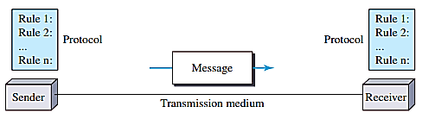
Ans: Message, Sender, Receiver, Transmission medium and Protocol.
1. Message. The message is the information (data) to be
communicated. Popular forms of information include text,
numbers, pictures, audio, and video.

2. Sender. The sender is the device that sends the data
message. It can be a computer, workstation, telephone handset, video camera, and so on.

3. Receiver. The receiver is the device that receives the message.
4. Transmission medium. The transmission medium is the physical path by which a message travels from sender to receiver. Some example coaxial cable, fiber-optic cable and radio waves.

5. Protocol. A protocol is a set of rules that govern data communications.

4. Explain Data Flow.
Ans: Communication between two devices can be simplex, half-duplex and full-duplex.
1. Simplex: In simplex mode, the communication is unidirectional, as on a one-way street. Only one of the two devices on a link can transmit. Keyboards and traditional monitors are examples of simplex devices. The keyboard can only introduce input; the monitor can only accept output.
2. Half-Duplex: In half-duplex mode, each station can both transmit and receive, but not at the same time. When one device is sending, the other can only receive, and vice versa. Walkie-talkies and CB (citizens band) radios are both half-duplex systems.
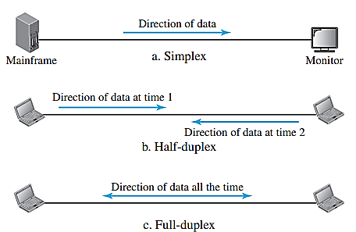
3. Full-Duplex: In full-duplex mode (also called duplex), both
stations can transmit and receive together. One common example of
full-duplex communication is the telephone network. The full-duplex
mode is used when communication in both directions is required all
the time.

5. Discuss Networks Criteria.
Ans: A network is the interconnection of a set of devices capable of communication. In this definition, a device can be a host such as a large computer, desktop, laptop, workstation, cellular phone, or security system.
The most important of these are performance, reliability, and security.
- Performance: Performance can be measured in many ways, including transit time and response time. The performance of a network depends on a number of factors, including the number of users, the type of transmission medium, the capabilities of the connected hardware, and the efficiency of the software. Performance is often evaluated by two networking metrics: throughput and delay.
- Reliability: Reliability means a network works properly with fewer failures. It also means the network can recover quickly when a problem occurs.
- Security: Security means protecting network data from unauthorized access and damage. It also ensures data can be recovered after security problems or data loss.
6. Explain Physical Structure for type of connections.
Ans: A network is two or more devices connected through links. There are two possible types of connections: point-to-point and multipoint.
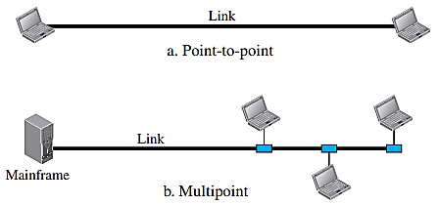
- Point to Point: A point-to-point connection provides a
Dedicate link between two devices. Most point-to-point
connections use an actual length of wire or cable to connect
the two ends. a point-to-point connection between the remote
control and the television’s control system.
- Multipoint: A multipoint (also called multidrop) connection
is one in which more than two specific devices share a single
link.

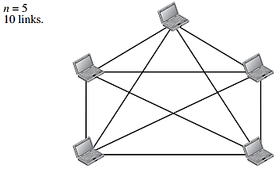
7. Categorize the four basic topologies in terms of line configuration.
Ans: Mesh, Star, Bus and Ring Topology.
i. Mesh Topology: In a mesh topology, every device has a dedicated point-to-point
link to every other device. It is reliable and secure because if one link fails, other
devices can still communicate. In other words, we can say that in a mesh topology,
we need n (n – 1) / 2 duplex-mode links. Its main disadvantages are high cost, more cables,
and more I/O ports are needed.
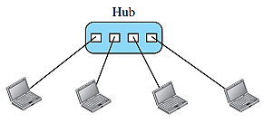
ii. Star Topology: In a star topology, each device has a dedicated point-to-point link
only to a central controller, usually called a hub. The devices are not directly linked
to one another. A star topology is less expensive than a mesh topology. The star
topology is used in local-area networks (LANs).

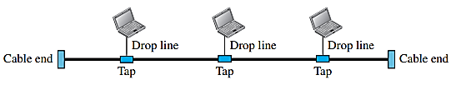
iii. Bus Topology: The preceding examples all describe point-to-point
connections. Bus topology was the one of the first topologies used in
the design of early local area networks. Traditional Ethernet LANs can
use a bus topology.

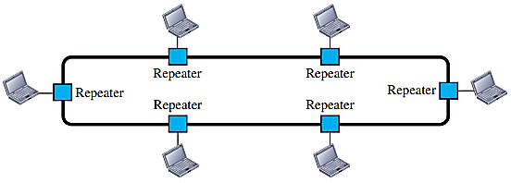
iv. Ring Topology: In a ring topology, each device has a dedicated
point-to-point connection with only the two devices on either side of it.
A ring is relatively easy to install and reconfigure. Ring topology was prevalent
when IBM introduced its local-area network, Token Ring.

Chapter 2
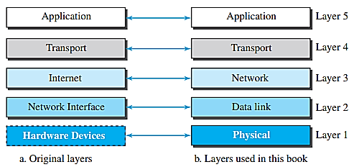
8. Explain Layer in the TCP/IP protocol suite.
1. Physical Layer: The physical layer is responsible for sending and
receiving individual bits between devices. It converts bits into electrical,
optical, or radio signals for transmission through cables or air. It is the
lowest layer of the TCP/IP protocol suite.

2. Data Link Layer: The data-link layer is responsible for transferring
data between two directly connected devices. TCP/IP does not define
any specific protocol for the data-link layer. It supports all the standard and proprietary protocols. The data-link layer takes a datagram and encapsulates it in a packet called a frame.
3. Network Layer: The network layer is responsible for sending data from the source computer to the destination computer. It selects the best route and forwards packets through routers using IP addresses. It uses IP protocol to deliver data and supports routing between different networks.
4. Transport Layer: The logical connection at the transport layer is also end-to-end. The transport layer at the source host gets the message from the application layer, encapsulates it in a transport layer packet. The transport layer should be independent of the application layer. User Datagram Protocol (UDP), is a connectionless protocol that transmits user datagrams without first creating a logical connection.
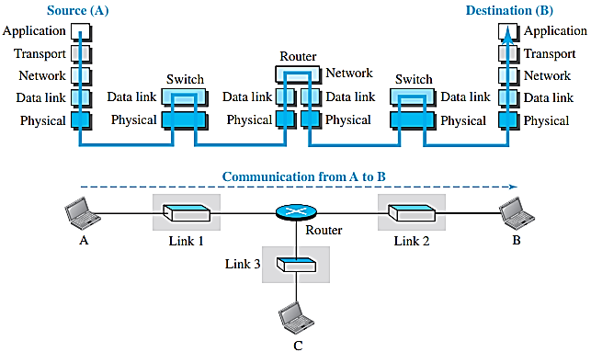
5. Application Layer: The logical connection between the two application layers is end to-end. Communication at the application layer is between two processes. The Hypertext Transfer Protocol (HTTP) is a vehicle for accessing the World Wide Web (WWW). The Domain Name System (DNS) is used by other protocols to find the network-layer address of a computer.
9. TCP/IP layer for communication through an internet.
Ans: When computer A sends data to computer B, the data passes
through switches and a router to reach its destination. Both
computers use all five layers, while the router uses only three
layers (Network, Data-Link, and Physical). A switch uses only
two layers (Data-Link and Physical) to transfer data between
devices.
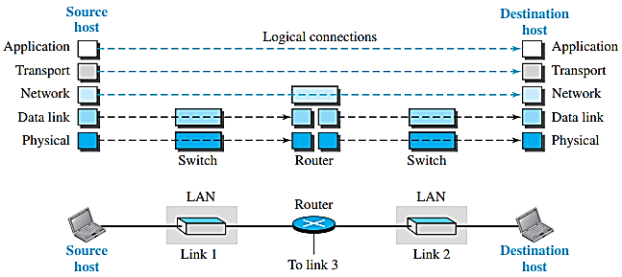
10. Logical Connections between layers of the TCP/IP protocol suite.
Ans: The Application, Transport, and Network layers work
from the source to the destination (End-to-End). The Data-Link
and Physical layers work between two directly connected
devices (Hop-to-Hop). Routers can change lower-layer data,
but link-layer switches do not change the packet.

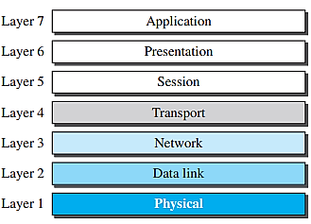
11. Explain OSI Model.
Ans: The International Organization for Standardization (ISO) is a multinational body
dedicated to worldwide agreement on international standards. An ISO standard
that covers all aspects of network communications is the Open Systems
Interconnection (OSI) model. ISO is the organization; OSI is the model.
The OSI model is a layered framework for the design of network systems that allows
communication between all types of computer systems.

12. OSI Model vs TCP/IP Model.
OSI Model | TCP/IP Model
 | 1. It has 5 layers.
  1. It has 7 layers.
2. It has 3 upper layers: Application, Presentation, and Session. | 2. It combines these into one Application layer.
3. It has separate Physical and Data-Link layers. | 3. It also has separate Physical and Data-Link layers.
4. It is a reference model. | 4. It is a practical communication model.
5. Application, Presentation, Session, Transport, Network, Data-Link, Physical. | 5. Application, Transport, Network, Data-Link, Physical.

Chapter 3
13. i. Explain the term of Period(T) with diagram.
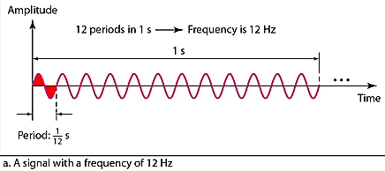
Ans: Period (T) is the time required to complete one full cycle of a periodic signal. It is measured in seconds (s).
Formula: T = 1 / f
Where,
- T = Time Period
- f = Frequency (Hz)
ii. Explain the term of Frequency(f) with diagram.
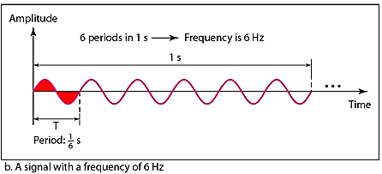
Ans: Frequency is the number of complete cycles of a periodic signal in one second. It is measured in Hertz (Hz).
a. Frequency is the rate of change with respect to time.
b. Change in a short span of time means high frequency.
c. Change over a long span of time means low frequency.
Formula: f = 1 / T
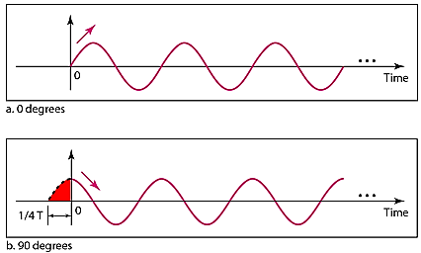
Where,
- f = Frequency
- T = Time Period

iii. Explain the term of Phase with diagram.
Ans: Phase describes the position of the waveform relative to time 0.
iv. Explain the term of Amplitude with diagram.
Amplitude is the maximum height of a wave measured from its normal (zero) position. It indicates the strength or size of a signal.
Example: If the maximum height of a wave from the zero position is 5 volts, its amplitude is 5 volts.

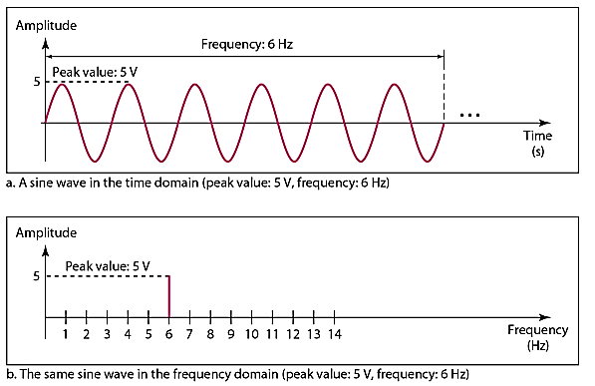
2. Figure 3.7 The time-domain and frequency-domain plots of a sine wave.

3. i. Composite Signals and Periodicity.
If the composite signal is periodic, the decomposition gives a series of signals with discrete frequencies.
If the composite signal is nonperiodic, the decomposition gives a combination of sine waves with continuous frequencies.
ii. Bandwidth and Signal Frequency.
The bandwidth of a composite signal is the difference between the highest and the lowest frequencies contained in that signal.

4. Math practices Example 3.1 to 3.8.

